Welcome to the ninth Newsletter for 2022.

The AGM
The Academy's Annual General meeting will be held on Thursday 20 October 2022 at 3.30 pm (Brisbane, AEST) Conference Centre, Queen Elizabeth II Courts of Law, level 12, 415 George Street, Brisbane and online (a link will be sent prior to the AGM).
The attached PDF document here includes:
1. Notice of AGM and Agenda
2. Proxy Nomination Form
3. Director Nomination Form
4. President's Report
5. Secretary's Report
6. Auditor's Report and Financial Statements
7. Draft Minutes of Previous AGM
All Director Nomination Forms must be returned to the Academy's Secretariat by 6 October 2022.
If you wish to submit a Proxy Voting Form this must be submitted to the Secretariat at least 48 hours prior to the AGM.
Please contact the Secretariat for further information:
AALSecretariat@academyoflaw.org.au

Congratulations

Please join me in warmly congratulating Academy Fellow Justice Jayne Jagot on her appointment to the High Court of Australia. As explained in the joint media release by the Prime Minister and by the Attorney-General dated 29 September 2022, available here, Justice Jagot will commence as a Justice of the High Court on 17 October 2022, upon the retirement of the Honourable Justice Patrick Keane AC.

The Academy’s website

There is a wealth of information on the AAL’s website:

https://academyoflaw.org.au/

Please look there for past and future events, prizes and scholarships, news and publications and a list of directors, officeholders and committees.

Fellows should log in to get the full benefit of the website. For example, once logged in, a Fellow can communicate with another Fellow via the website.

If your details are not recorded accurately, please let the Secretariat know. Similarly, if you see any other inaccuracies or indeed have suggestions for improving the website, please notify the Secretariat.

Donations to the AAL’s Public Fund

It is very pleasing to note the steady number of donations to the AAL’s charitable purposes via the Public Fund, which has DGR status. I note with many thanks a donation as recently as last month where a Fellow most generously gave $2500. While most donations are by Fellows, a recent substantial gift came from a practitioner who, while not a Fellow, had attended some of the Academy’s public events. The AAL is most grateful to him and to all donors.

Donations may be made via the website:

https://academyoflaw.org.au/Donations

2022 AAL Annual Essay Prize

The deadline for submitting an essay was 31 August 2022.

The essay topic for the Prize in 2022 is as follows:

“What are one or more reforms that could be made to remedy deficiencies in the administration by Australian courts of the criminal law as it applies to minorities or disadvantaged groups?

Note: The essay should not focus on funding by government.”

The distinguished judging panel is constituted by AAL Fellows Emeritus Professor Kate Warner AC, Professor The Hon William Gummow AC QC and Mr Tim Game SC. I thank them for their willing participation. We expect to announce the winner of the $10,000 Essay Prize in the next weeks.

Legal studies prize for secondary students

The AAL has been investigating the feasibility and logistics of a Year 11/12 Legal Studies prize, with the likely focus being on Year 12.

The idea is to award a prize to the top student in Legal Studies, however named, in each State and Territory, so eight prizes in all.

So far, we have been unable to answer a difficult question: how best to identify the top Legal Studies student in each jurisdiction.

If you can assist, please contact Professor Gino Dal Pont or me.

Forthcoming events

18 October 2022, joint symposium with the Australian Academy of Science

5 PM for 5:30 PM, at the Shine Dome, 9 Gordon Street, Acton ACT

The working title for the joint symposium is “The Science and the Law of Prohibited Drugs”.

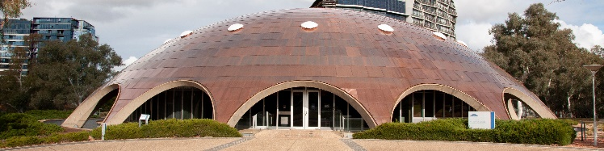

The Shine Dome

This annual joint event is being organised with the President of the Australian Academy of Science, Professor Chennupati Jagadish AC. The AAL is most grateful to Professor Jagadish and the officers of the AAS for their work in putting this event together.

I am very pleased to report that the Hon Lucy McCallum, Chief Justice of the Australian Capital Territory, has kindly agreed to chair the symposium.

The speakers invited by the AAS are:
Professor Arthur Christopoulos FAA FAHMS –
https://research.monash.edu/en/persons/arthur-christopoulos
and
Scientia Professor Carla Treloar –

https://www.unsw.edu.au/staff/carla-treloar

The speakers invited by the AAL are:

The Honourable Acting Justice Richard Refshauge, who is in charge of the ACT Drug and Alcohol Court, and Nicholas Cowdery ÄM KC who was Director of Public Prosecutions for NSW from 1994 to 2011. He is a member of the Australian Drug Law Reform Initiative (ADLaRI) at UNSW.

Refreshments will be served.

There will be no registration charge for Fellows of the Academies. For non-Fellows, excluding students, the charge will be $25, and for students the charge will be $10. Registration for remote attendance will be free. The registration details are available here.

Thursday 20 October 2022: the AAL’s 2022 Patron’s Address

The time of this Address will be 4.30 PM (QLD, AEST): 5.30 PM (NSW, VICT, TAS, ACT - AEDT): 5.00 PM (SA - ACDT): 4.00 PM (NT - ACST): 2.30 PM (WA - AWST) online.

The venue is the Conference Centre, Queen Elizabeth 11 Courts of Law, Level 12, 415 George Street, Brisbane and online (a link to be sent prior to the event)

This year’s Patron’s Address will be given by the Hon Patrick Keane AC, who will have retired as a Justice of the High Court of Australia on 16 October 2022. The title of his Address is “Leave those Blue-Eyed Babies Alone: Rhetorical Limitations on Parliamentary Sovereignty.”

Since early in the life of the Federation, the High Court has deprecated the deployment of extreme and distorting examples of bad laws that Parliament might make as an argument for taking a narrow view of legislative power. Nevertheless, the rhetoric of the extreme example exhibits a continuing appeal. The appeal of this rhetorical strategy echoes elements of a long-standing anti-democratic tradition within the common law.

Justice Tony Besanko, Deputy President of the AAL, will chair the proceedings.

Please put this date in your diary. The flyer is here and the registration details are here.

Wednesday 2 November 2022: 5:00 PM - 7:00 PM

Michael Coper Roundtable: Where There's a Will There's a Lawyer: The Dobell Case and Subsequent Litigation about the Archibald Prize

Venue: High Court of Australia, 31 Parkes Place, Parkes, Canberra ACT 2600

The speaker will be Graeme Neate AM FAAL. He has been the President of the ACT Civil and Administrative Tribunal since 2017. Before that he was a Commissioner with the Queensland Industrial Relations Commission, having been President of the National Native Title Tribunal from 1999 to 2013. In his (somewhat scarce) spare time he paints pictures – but not portraits.

The Archibald Prize for portraiture has been awarded annually for more than 100 years. The exhibition of finalists attracts public interest, controversy and occasionally court cases. In this presentation, Graeme Neate will consider litigation in the Supreme Court of New South Wales, starting with the famous Dobell case of 1944. He will discuss legal issues arising under the will which established the prize, how judges have decided whether the prize should be awarded, some of the personal implications of the litigation for parties and other participants, and some outstanding legal issues which, even if they do not provoke more court cases, might prompt lively discussion.

The flyer is here and registration details here. This is a Fellows only event.

9 November 2022, Event for Fellows in London

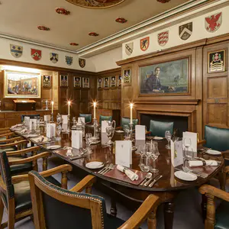

There will be an AAL dinner in London at which Professor Rachael Mulheron KC (Hon), Professor of Tort Law and Civil Justice, School of Law, Queen Mary University of London, will speak on a legal topic of current interest and importance.

I give my thanks to Desmond Browne CBE, KC for his great help. He has arranged for the dinner to take place at the Small Pension Room in Gray’s Inn, 8 South Square, London.

This event is now fully subscribed.

8 – 10 September 2023

Joint event with the Australian Law Journal and the Australasian Institute of Judicial Administration: Enduring courts in changing times

To mark some important national legal bicentenaries, a 2½ day joint event with the Australian Law Journal (ALJ) and the Australasian Institute of Judicial Administration (AIJA) is planned for Friday 8 – Sunday 10 September 2023. Examples of those legal bicentenaries are, for New South Wales, the Third Charter of Justice promulgated on 13 October 1823 establishing the Supreme Court and, for Tasmania, the first sitting of the Supreme Court of Van Diemen’s Land on 10 May 1824.

I thank Justice François Kunc for this initiative. Emeritus Professor David Barker AM and Justice Geoff Lindsay are on the subcommittee, as is AAL Fellow Justice Steven Rares, as a member of the Council and immediate past President of the AIJA. I am pleased to say that Chief Justice Alan Blow AO and Justice Stephen Estcourt AM of the Supreme Court of Tasmania have also joined the small committee. Andrew W Smith of the New South Wales Bar has also accepted my invitation to assist with the planning.

The idea is to have one part of the event physically in Tasmania and another part in New South Wales, but with a commingling of speakers and topics.

The Chief Justice of Tasmania, the Hon Alan Blow AO, and the Chief Justice of New South Wales, the Hon AS Bell, have approved the project. The Chief Justice of Australia, the Hon Susan Kiefel AC has also agreed to attend and address this event. A number of other distinguished speakers, judges and former judges, academics and practitioners have been invited and are willing to be involved.

This promises to be a major event, similar to the “Future of Australian Legal Education” conference held by the AAL and the ALJ in 2017.

Prospective speakers, including from overseas, have now been contacted and they have all responded with enthusiasm. The next step is for the organising committee to map out the shape of the conference.

Recent events

9 September 2022 – Causation Conference, Perth, sponsored by Herbert Smith Freehills, the Australian Academy of Law and the University of Western Australia Law School.

I thank Dr Elise Bant FAAL, Professor of Private Law and Commercial Regulation, UWA, Professorial Fellow, University of Melbourne, and her team for their work on this important conference.

The following themes were addressed:

Causation, Contract and Loss
Material Contribution and 'But For' Tests of Causation

Decision Causation

Science and Causation

Causation in the Criminal Law

Causation in Torts

Understand NESS (necessary for the sufficiency of a sufficient set)

The conference program is available here.

I thank Professor Bant for her report, which I have summarised:

With the efforts of the AAL, HSF and UWA networks, we ended up attracting around 100 online and in person registrations. The room felt full and vibrant all day and online participants generally lasted the distance. Considering the dense nature of the conference theme, and the challenge of attending a full day’s proceedings remotely, this was particularly welcome.

The eminent presenters were hugely impressed by, and in turn impressive in, the day’s proceedings.

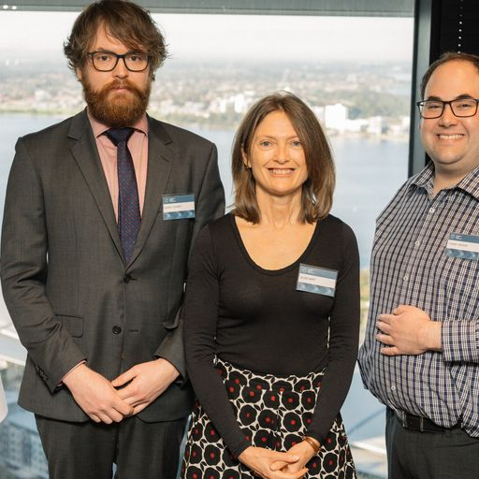

The convenors of the conference, from left: Henry Cooney (UWA), Elise Bant FAAL (UWA) and Yannis Vrodos (HSF)

There was a very significant number of judicial attendees, most of whom remained for the full day. Senior members of the Bar also contacted Professor Bant to express their appreciation of the quality of the conference.

The AAL funding support contributed significantly to the in-person attendance of Professor Richard Wright, Justice Julie Ward and Associate Professor Neil Foster. Their decisions to attend in person in turn persuaded Dr Thomas Grosse-Wilde and Dr Johannes Meyer to fly, on their own accounts, from northern Europe to Perth for the event.

The Hon Tony Besanko, Deputy President of the Academy moved the vote of thanks. He said:

“It has been a full day and a very informative day.

I would like to make some very brief comments on behalf of the Australian Academy of Law which is one of the three sponsors of this Conference.

The members of the Academy come from all parts of the legal community, including academia, the practicing profession and the judiciary. The Academy’s objects include the promotion of the highest standards of legal scholarship, legal research, legal education, legal practice and the administration of justice and the promotion of continuous improvement of the law and the operation of the legal system. The Academy also aims to provide forums for the exchange of views amongst all branches of the legal community on matters as to the operation of the legal system.

This conference and the papers of the speakers has made a significant contribution in terms of insights into private, commercial and criminal law doctrines in which causation plays a part.

It has addressed causation in all its contexts and complexities with speakers of national and international reputation. It certainly advances scholarship and brings together academia, the judiciary and legal practitioners. The Academy is both proud and privileged to be a sponsor of this conference.

Thank you and congratulations to the speakers and organisers.”

15 September 2022 5.00 pm (Perth) 7.00 pm (AEST)

The Palmer Act: The Rule of Law under State Constitutions

I thank Professor Sarah Murray for this account:

On Thursday 15 September the Australian Academy of Law and the WA Chapter of the Australian Association of Constitutional Law jointly held an event exploring the rule of law in the context of the Iron Ore Processing (Mineralogy Pty Ltd) Agreement Amendment Act 2020 (WA). Dr Murray Wesson (UWA Law School) discussed the status of the rule of law in Australian constitutional law and how the rule of law featured in Palmer v The State of Western Australia [2021] HCA 31 and Mineralogy v The State of Western Australia [2021] HCA 30 while Dr Paul Burgess (Monash Law School) explored the broad theoretical basis and scholarship behind the rule of law.

Over 70 attendees were present at the seminar and it was also recorded.

22 September 2022 – NT Event

Austin Asche Oration in Law and Governance

Because of the National Day of Mourning public holiday, this event has been postponed to a date to be fixed.

The topic is “Executive discretion in a time of COVID-19 – promoting, protecting and fulfilling human rights in the contemporary public health context.” The speaker will be Emeritus Professor Ros Croucher AM, President of the Australian Human Rights Commission.

Projects for the Public Fund

A real success of the new Public Fund for 2021 and for 2022 was the expenditure of part of the charitable donations on the First Nations Scholarship project. In both years, not only was there a substantial scholarship of $5000 awarded to a First Nations final year law student, but also individual AAL Fellows volunteered to mentor the scholar.

If you have a proposal for a scholarship or other educational project for the Public Fund, please let me know.

If you wish to donate to the fund, the starting point is here: or please contact the Secretariat or me.

Grants

The AAL is in a position to consider applications for grants, in accordance with its Constitution.

If you consider that you have a project which would warrant support by the AAL, then please get in touch with the Secretariat as soon as practicable.

For example, a suitable project might be the publication of a book, or a lecture or a seminar or a lecture or seminar series, or a research project.

New Fellow

Please join me in extending a warm welcome to the following distinguished lawyer who has accepted the Board’s invitation to become a Fellow of the Academy:

Professor Anita Stuhmcke, Professor and Dean of the Faculty of Law at the University of Technology, Sydney.

Alan Robertson
President
alan.robertson.sc@gmail.com
0404850364

